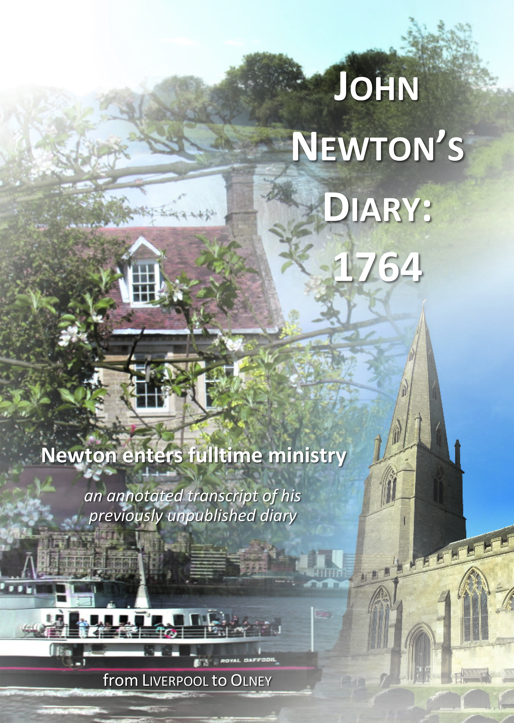

www.johnnewton.org Registered Charity No. 212939

*£5: 44 page A4 from* www.johnnewton.org

**First ever publication from John Newton’s Diary!**

*In 1764 Newton moved from secular employment into fulltime ministry.*

*This is his complete diary for 1764, annotated and illustrated.*

John Newton’s diaries are an essential source for a fuller understanding of the man and his ministry. Here we discover fascinating details of his public role as a young preacher and pastor, and his early evangelical networks. Here the veil is pulled back on Newton’s inner piety – his passions, anxieties, loves, and deep sense of his own sinfulness – as he pours out his heart before God in secret.

**Andrew Atherstone**, *Latimer Research Fellow, Wycliffe Hall, Oxford*

John Newton was certainly one of the most influential of the 18th C evangelical leaders, in and beyond the Church of England. Arguably, he was the greatest ‘all-rounder’, but he very especially shone in his pastoral ministry, whether by letter or ‘one-to-one’. Newton’s diary for 1764 reveals the heart of this already humble and godly man as he traced the course of his move into fulltime ministry in the Church of England.

**Tony Baker**, *Trustee, The John Newton Project*

Books abound on preaching, the Christian life, and counselling. Perusing the diaries and letters of John Newton put the vast majority of them in the shade. Accompanying Newton’s diary of this crucial year of his life are Marylynn Rouse’s meticulous and detailed footnotes, and the result is a work for which we should all be grateful.

**Peter Barnes**, Moderator General of the Presbyterian Church of Australia

The value of this diary of John Newton’s is that it speaks to us from a time long distant and so undistracted by our present concerns. It has a spiritual freshness which edifies. Here are words from a servant of the same Lord as we worship, whose service both challenges our inadequate godliness and encourages us to persevere.

**Peter Jensen**, *former Archbishop of Sydney*

This record of the earliest days of Newton’s ministry leads to the remarkable discovery that the disarming humility, evangelistic zeal, and deep commitment to pastoral care that would characterize Newton’s future ministry were present right from the start. Spiritual leaders young and old will be both encouraged and convicted by Newton’s biblical convictions and tender demeanor.  Clearly, by God’s grace, Newton was wise beyond his years!’

**J. Todd Murray**, *Associate Pastor, Grace Immanuel Bible Church, Author of Beyond Amazing Grace*

This is a great achievement. I choose my words carefully.  To be reading his diary for the first time since his death, to see the footnotes and explanations, all that is terrific.  What a gift to the church. This is your lifetime's work, restoring Newton to the church, showing the world the real stature of this man of God.

**Geoff Thomas**, *former pastor of Alfred Place Baptist Church, Aberystwyth*